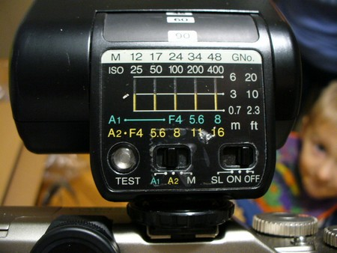
ASA 25 | ASA 50 | ASA 100 | ASA 200 | ASA 400
NO | No | ASA 100 - F4 | ASA 200 - F5.6 | ASA 400 - F8
ASA 25 - F4 | ASA 50 - F5.6 | ASA 100 - F8 | ASA 200 - F11 | ASA 200 - F16
All with a Max of 20 feet (6 meters) , no closer then 2.5 feet (0.7 meters)
My research for a Fujifilm GA - I will try to find an manual. This is from a few forums.
Well, nobody has the fuji flash manual. The image and information found off the web.
- apparently the GN is 24 per 100 ISO (marked above GNo (m) 24 opposite the 100 iso mark, there it is.
- a button ON / OFF / SL, I found, and SL must be for "Slave", the flash works if another flash illuminates the cell.
- a button "TEST", no problem
- an A1 / A2 / M button, which changes the display of the table above:
- A1: Green color so usable flash from 0.7m to 6m for 100 to 400iso and up to f / 8
- A2: Yellow color therefore usable flash from 0.7m to 3m for 25 to 400 iso and up to f / 16
- M: Manuel I guess, thoroughly ignoring the built-in flash.
2 examples:
1- Fill-in flash on the outside, I set my GaZi for the background (I always work in Manual mode), I set the flash according to the movie and the distance of the subject on A1 or A2, There you go ?
2- insufficient light, indoor photos without dedicated lighting: the GaZi on 1/60 or 1/125, diaphragm according to the desired depth of field, and flash in A1 or A2 according to the diaph and the film (and the distance of course) ...

Now, if I compare to the Minolta flash (3600HSD) or the Vivitar 285 ...
With the fuji strobe GA:
- no TTL, it's just a simple GN24 flash to computer with built-in trigger cell and standard shoe,
- the GaZi's flash cell is not used, unlike the flash unit
- in slave mode, no TTL either, moreover the cell of the flash only takes into account the distance and the illumination flash-subject, and not at all film-subject, unlike the Minolta which "discusses" with the device and Vivitar which can move the cell through the cable SC3.
- the number of fuji guides is weak ...

Finally, I may have been able to settle for the Vivitar 285?
Is there any advantage to using the Strobe GA on the GaZi (some hidden function ...)?
The flash can not be TTL, because the cells are on the front of the device ...
On the other hand, when using this flash, there is no indication in the GaZi viewfinder, nor speed limitation (1/45 with the built-in flash), nor flash charging indicator.

You can not force the built-in flash to fire in program mode if the background is light enough to make the camera think it needs no flash. There is no way to force flash in full-auto mode. However, it will Always fire in aperture, a-synch, and manual modes if the flash is popped-up. Your minimum shutter speed using the built-in flash is limited 1/45. F-stop will depend on film speed.
For the built-in flash, the guide number is 12 for ISO100, 24 for ISO 400.
Farthest flash distance at ISO 100 is 2.7 meters with lens at 55mm and 1.7M at zoomed to 90mm. Farthest flash with ISO 400 film is 5.3 meters with the lens at 55mm and 3.5 meters at 90mm.
The manual warns of using other makers external flash units with a signal pin which can apparently get stuck in the hot shoe. Use external flash units in manual mode. The shutter speed is not limited to 1/45 sec which may result in long exposures. Do not use built-in and external flash units together. Fuji recommends its own flash unit, the strobe GA which will allow operation in auto mode. When ISO 100 film is used and aperture to F8, you can take pictures in automatic exposure mode.

